Quarries on the Bennachie Colony

There are two quarries on the Bennachie colony, this one and another about 50 m to the north in the woods.

This quarry was probably worked by the colonists from about 1850 as it is shown on the Ordnance Survey 25" map surveyed in 1867 but not on an earlier one produced in 1844 for the division of the commonty. However the commonty map does not show any of the other quarries in the area. Working probably stopped before 1899 as it does not show up on a revision of that date.

On the quarry walls there are no signs of tool marks and so the rock was probably split along the sub-horizontal joints and other fissures using large iron wedges and big hammers. Once on the quarry floor the large blocks would have been worked into blocks of the desired size by the plug and feather method. In this a row of slots were made with a pointed hammer no more than 10 cm apart. Then wedges were placed in each slot and hit in turn with a hammer. Eventually the block split along the line with a cut almost as clean as if cut with a saw.
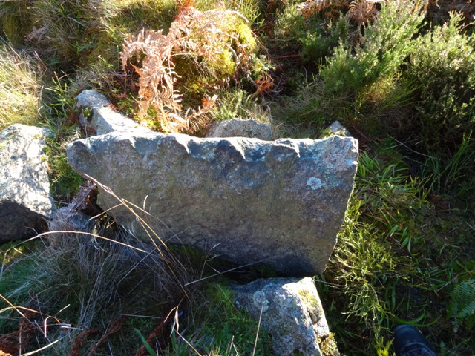Granite block cut with Plug and Feather method.

The waste from the trimming would have been dumped in the spoil heap which can be seen on the south side of the road.
Very large block of granite in Kemnay Quarry being split by Plug and Feather method.
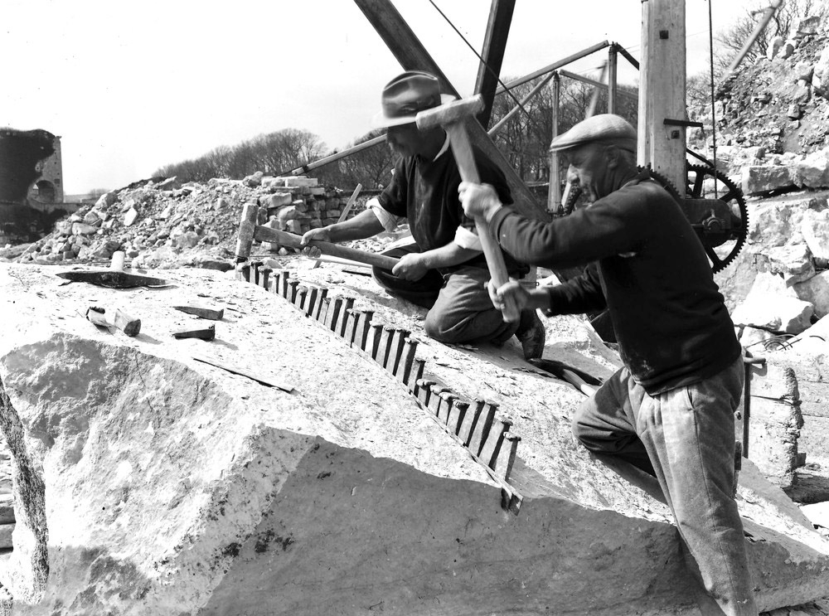
It has been suggested that the colonists opened this quarry for stones for their houses. However this is thought to be unlikely as the colonists would have been keen to get their houses built and their land cleared of stones very quickly. They would therefore have had as many stones as they wanted without the time and effort of quarrying. Some of these would have been large enough to have needed splitting to make them moveable. Others may have been trimmed to make them better building stones. Look at the root balls of the wind blown trees to see how many stones there are. Also look at the masonry in the houses to see if you can find stones cut with the drill and feather method. Also check to see if they have rounded corners, in which case they would have been field stones, perhaps with some trimming to make them better building stones.

The second quarry is probably newer as it is not on the 1867 map but the road past it is shown. There is a copy of a one year lease of a quarry to James Esson in 1870. This is described as being to the north of Littlejohn's croft (Shepherds Lodge), whereas the first quarry is clearly to the west of the croft. So this one must have been opened up at about that time.

If in fact the products of the quarry were exported for building cottages and farms for the Balquhain Estate, the output would have likely been limited to the most important building stones. These would have been the lintels and sills for windows and doors, corner stones, the tabling (the flat stones running up the gable ends) and the spur stones (the shaped stones at the top of each corner to stop the tabling from sliding down). They would have been expensive to make in term of time to extract and to transport them to the place where needed. This would have been difficult on the paths and roads available at the time.

A quick survey of this quarry has been made and from this it is estimated that about 380 cu m or 160 tonnes of granite were exported. To equate this to the number of farms and cottages that could have been built from it, two houses have been examined. Both show up on the 1866 Ordnance Survey maps in their present form so were probably built at about the same time that the quarry was in use. Burnside of Braco is a small cottage which has a door and two windows in the front and a small window in the back. All the main stones, lintels, sills, corner stones and gable end caps are well dressed and are of Bennachie granite. The majority of stones in the remainder of the walls show rounded corners and of various lithologies. They are almost certainly field stones that have been dressed to some extent. The total amount of quarried stones amounts to about 3.75 cu m. Broadsea, the second house, is a much grander affair. It is the standard rectangular shape but with a wing out from the back. The front wall is made entirely of dressed blocks of Bennachie granite although the side and back walls are probably field stones although of better quality to those at Burnside. The total amount of quarried stone used to build Broadsea is about 25.5 cu m. A further interesting thing about Broadsea is the the attached U shaped steading is almost entirely build of dressed stones of Bennachie Granite. The volume here has not yet been estimated but is likely to be of the order of 50 cu m. So this little quarry could have been the source for about five farms and a few cottages.

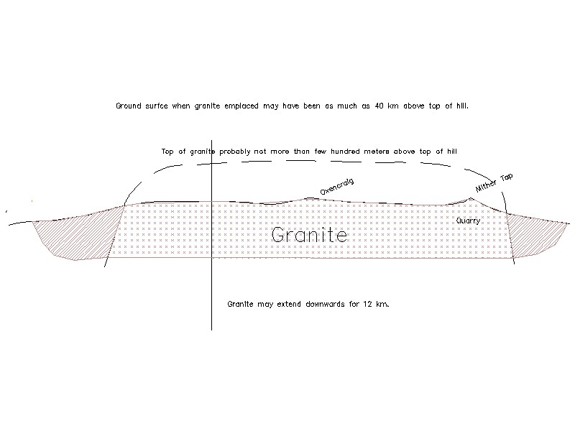
The granite in this quarry is similar to that over most of Bennachie and is a course biotite granite which is often porphyritic. This means that it contains large crystals of feldspar often up to 5cm long, which can easily be seen on worn surfaces like on the Maiden Causeway or on some of the weathered blocks lying around the colony. The granite is essentially the same as that found in many locations between here and the Cairngorms. Geologists argue that these represent one large intrusion extending from the Monadliath mountains as far east as Peterhead. It was intrude about 410 million years ago. The granite may extend downwards for about 12 km without much change until it passes into other rock types. The quartz grains in the granite both here and in the Cairngorms is often smoky. In the latter case this leads to the formation of the semi precious stone known as Cairngorm. Unfortunately the crystals here are never large enough to be of any significance but their presence indicates that this is probably near the top of the intrusion. The general course grained nature of the granite indicates that it was intruded very deep under ground, indeed it is estimated that as much as 40 kilometres of rock have been eroded since it was emplaced.

Andrew Wainwright
June 2017

